**JAVA 8 - JDBC ODBC BRIDGE ERROR** in eclipse

**STEP 1:**

In Java 8, jdbc odbc bridge is no longer used and thus removed from the JDK, to use Microsoft Access database in JAVA, we need 5 extra JAR libraries.

1. hsqldb.jar
2. jackcess 2.0.4.jar
3. commons-lang-2.6.jar
4. commons-logging-1.1.1.jar
5. ucanaccess-2.0.8.jar

**STEP 2:**

To get these files go to the following link and download the latest version.

<http://sourceforge.net/projects/ucanaccess/files/>

or double click the icon below and extract the data…



**STEP 3:**

Inside the downloaded folder (UCanAccess-2.0.9.4-bin), find the “**five**” jar files which are listed above.

Add them into Eclipse,

Right click the project > build path > configure build path.

(which is shown in the image below)

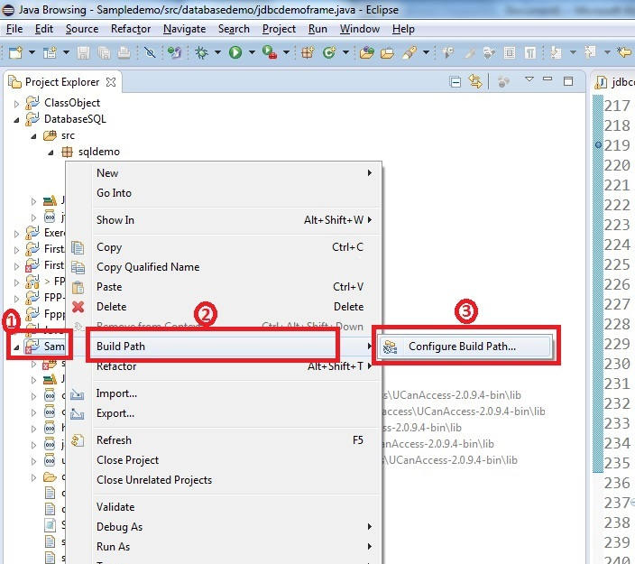

Click ‘Add External Jar’ and open those jar files.

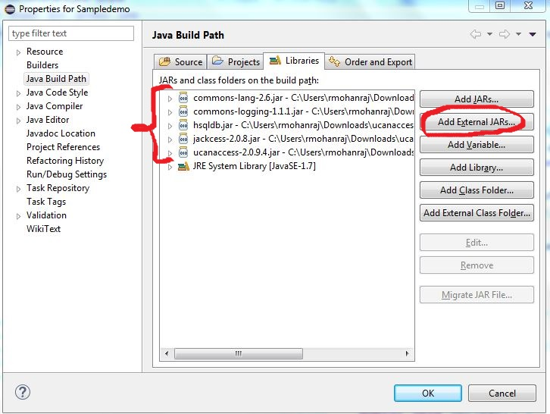

**STEP 4:**

Now change your code according to the “ucanaccess” plug-in, which is shown below.

